SECTION TWO – BOOK COVER



                          M A R C E L L A 

SECTION TWO FIRST PAGE

◎ M A R C E L L A 

*On The Surface of The Sun*  
  
“If they falter, they are men.   
  
If the fleece is well-received,   
  
then men are made better   
  
by women's good spirit.”

**M M I X**Hermosa Beach, California

SECTION 3 – TITLE PHOTOGRAPH ART

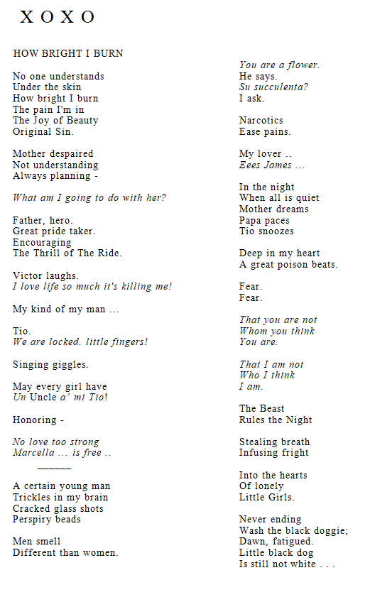

SECTION 3 – NARRATIVE TEXT - NOTE – I NEED THIS SYMBOL INSERTED MANY PLACES ξ  
  
◎ M A R C E L L A 

*On The Surface of The Sun*  
- DEDICATION -

MARCELLA, *On The Surface of The Sun* is my family Iliad. A drama with music, I came of age amidst intense family love, well-intentioned lies, and a smooth, slithering snake. Thanks, Buddha . . .

SKANDA – THEN CONTINUE ON STRAIGHT THROUGH UNTIL YOU COME TO THE END OF PAGE 61 WHICH CLOSES WITH:   
  
Tigresses in imaginary cages.

Marcella, Celitta, and The Mad Pride Girls rush to each other *en unison*.

Backs to backs, encircling, searching the night for danger.

Cobalt-blue essence flickers.

Flicker.

Extinguish.

Darkness.

* * * *